**STEPS TO MAKE SETUP OF NRF5340 ON VS CODE**

1. Install nrf commad line tool

Link- <https://www.nordicsemi.com/Products/Development-tools/nrf-command-line-tools/download>

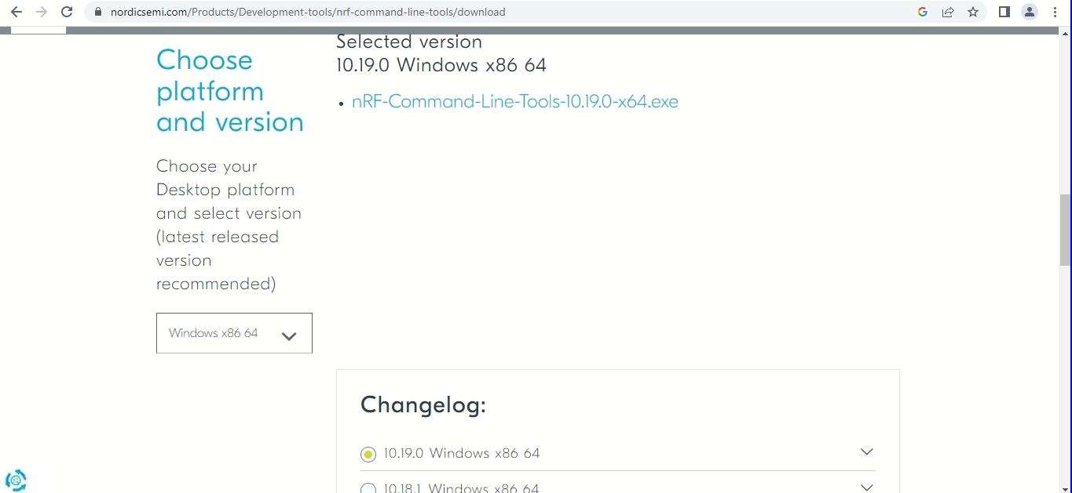

1. Install Nrf connect for desktop

Link- <https://www.nordicsemi.com/Products/Development-tools/nRF-Connect-for-Desktop/Download#infotabs>

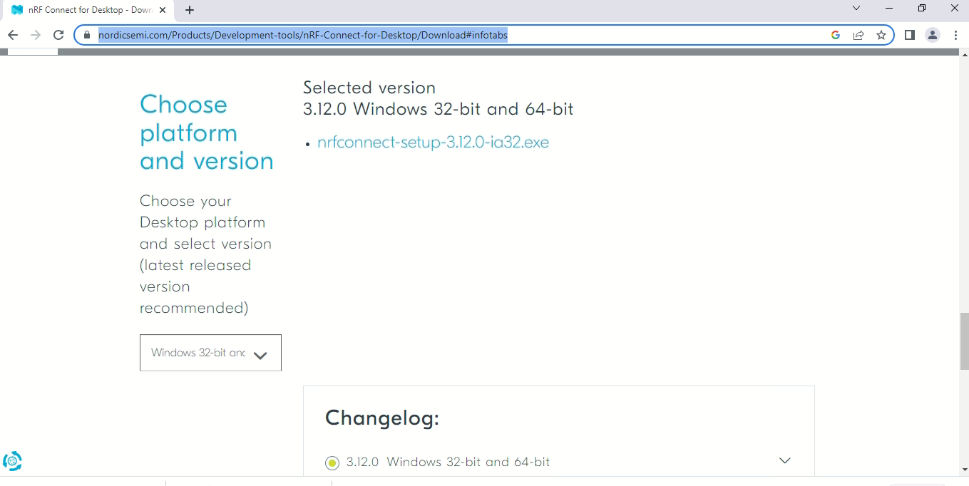

1. Install VS code.

Link- <https://code.visualstudio.com/docs/?dv=win>

1. Open nrf connect and install “toolchain manager” and click on “Open”.

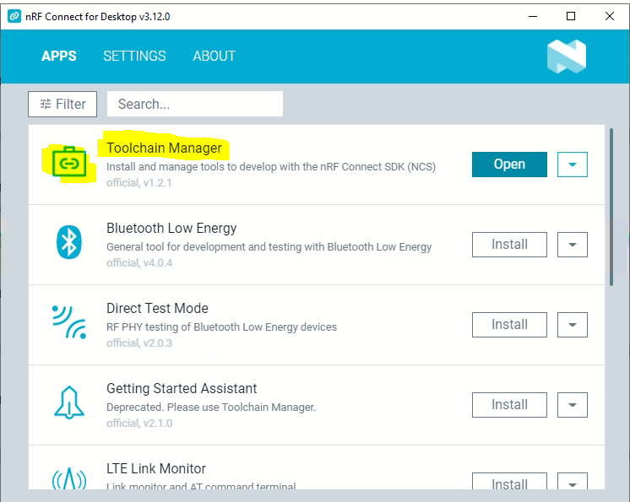

1. Then install the latest available SDK, in my case it was 2.2.0. 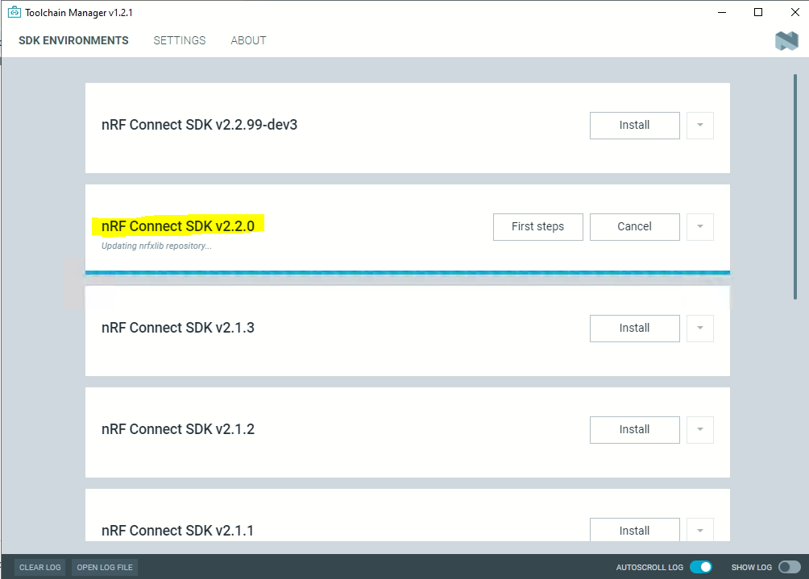
2. Click on “Open VS Code”

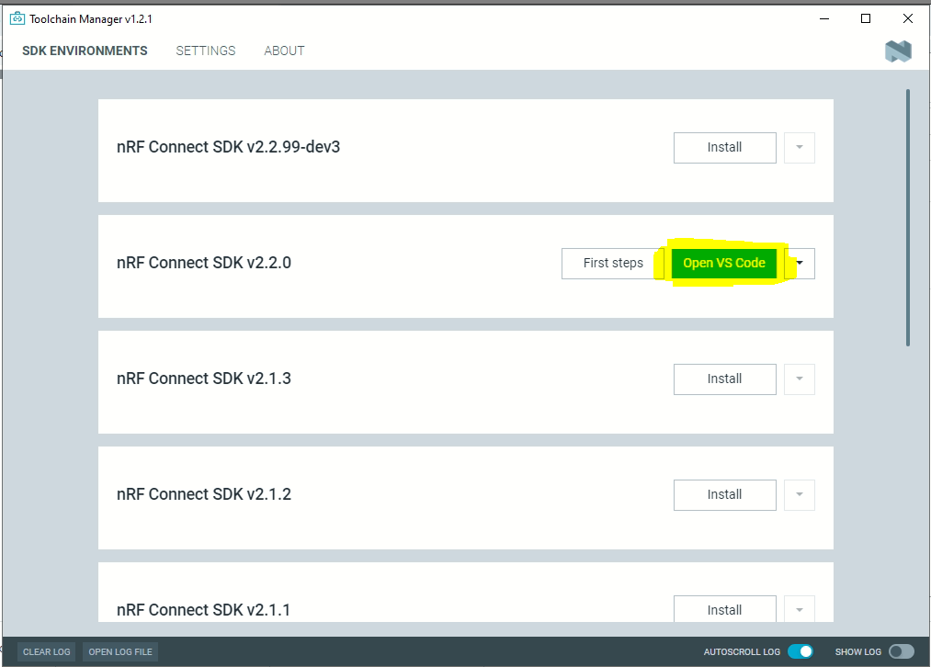

1. Click on “install missing extensions” 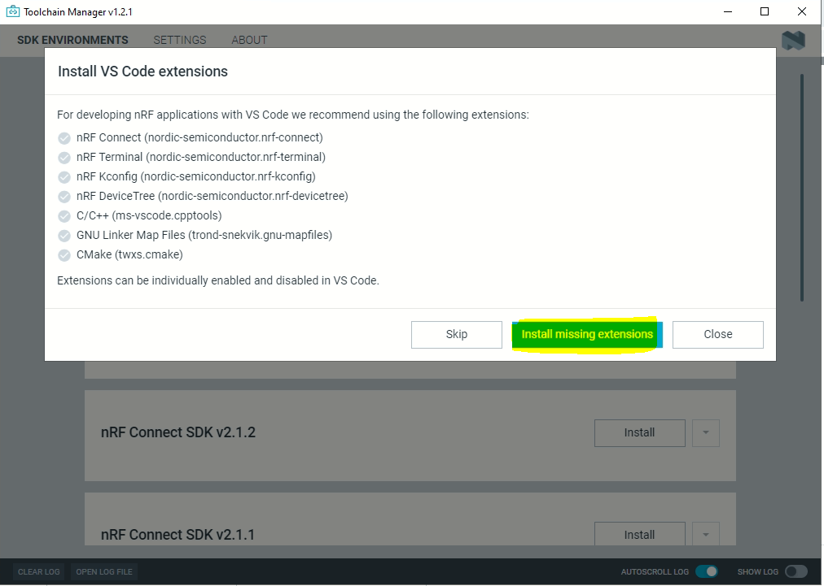
2. Click on “ Open VS Code” 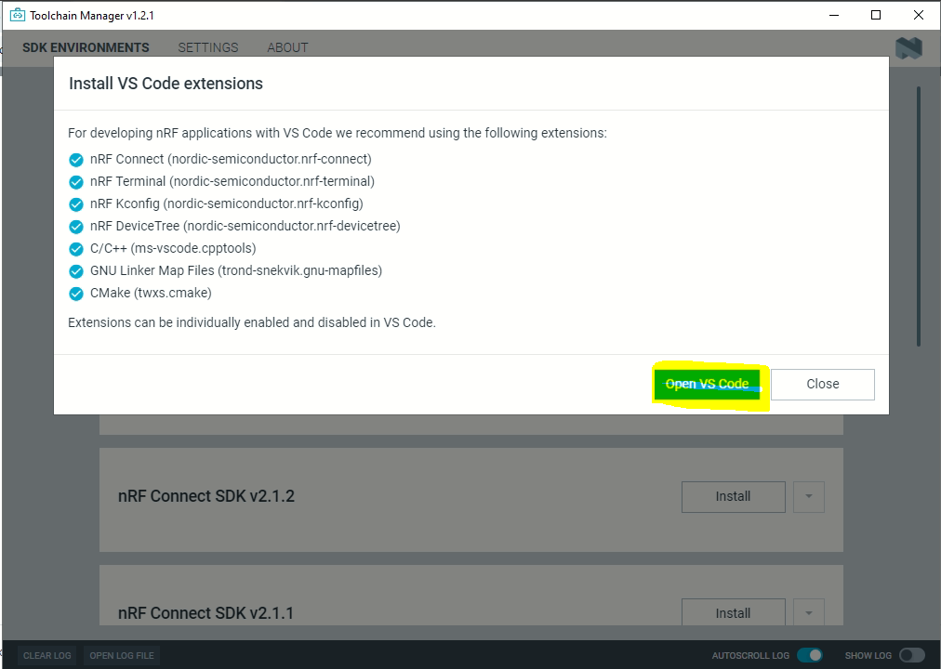
3. On welcome window for nrf connect select the following path 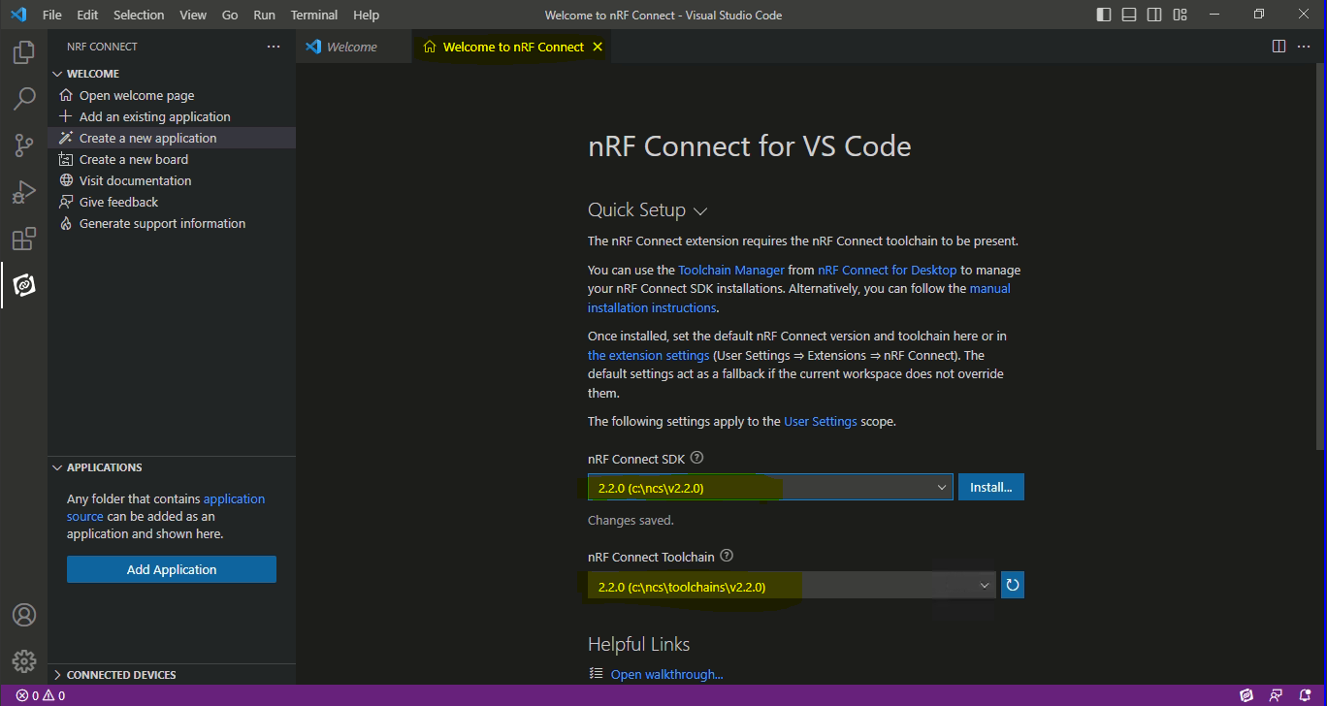
4. Click on nrf extension and select your desired example and create application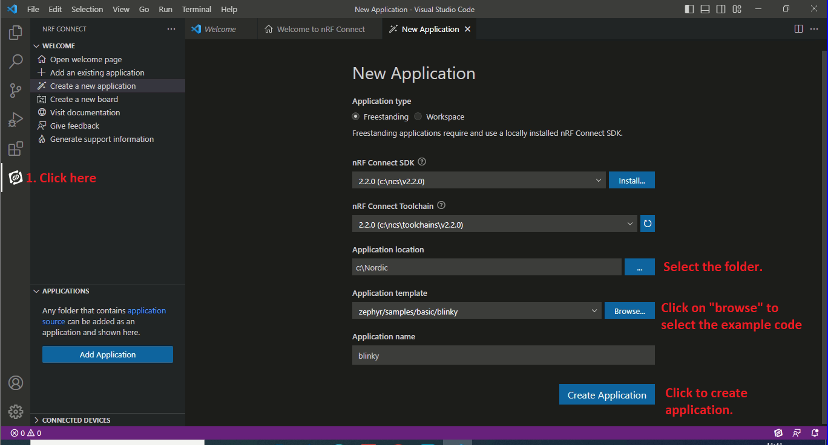
5. You will see blinky code under application head 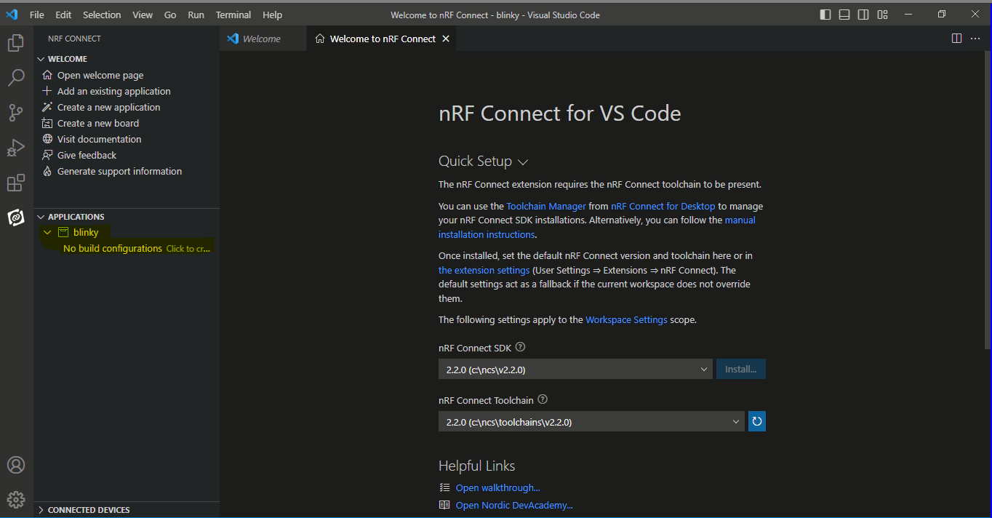
6. Click on “add build configuration”, a new window will come. 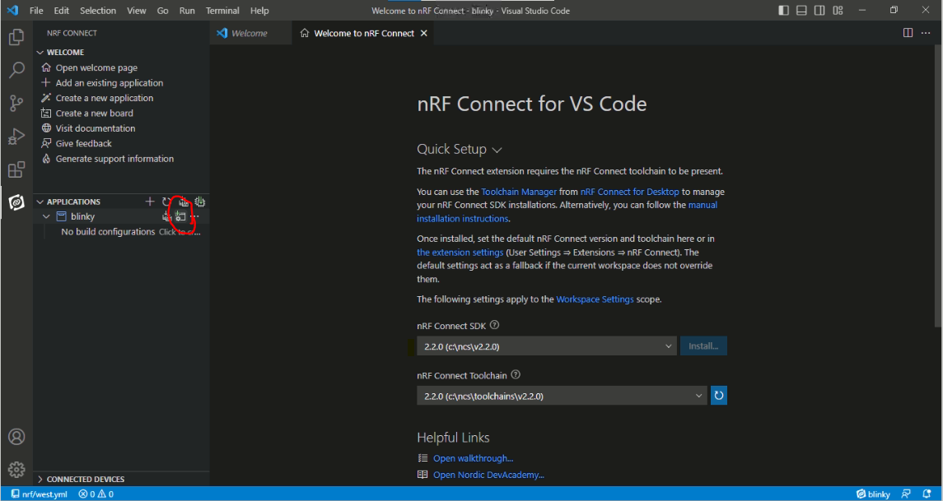
7. Select your desired board and click “build Configuration”.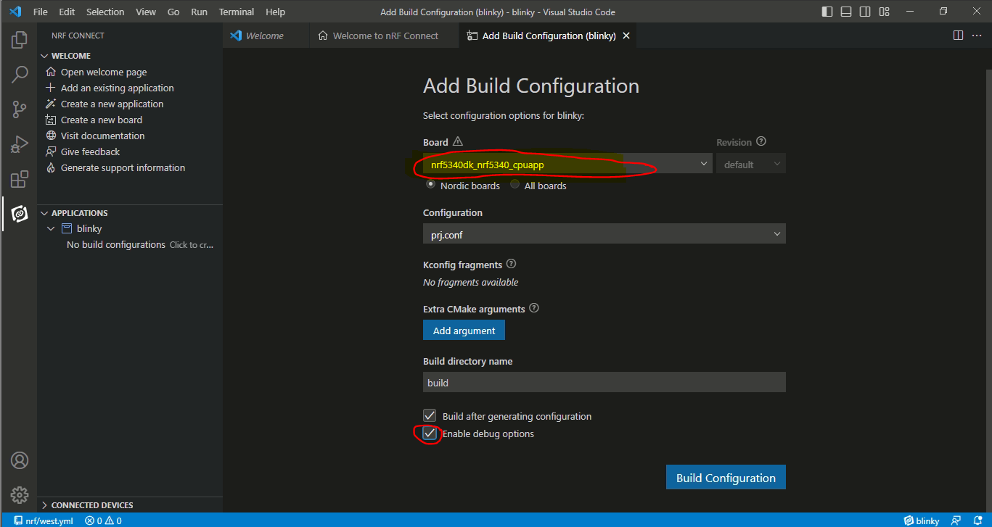
8. After build configuration you will see the following view on your screen 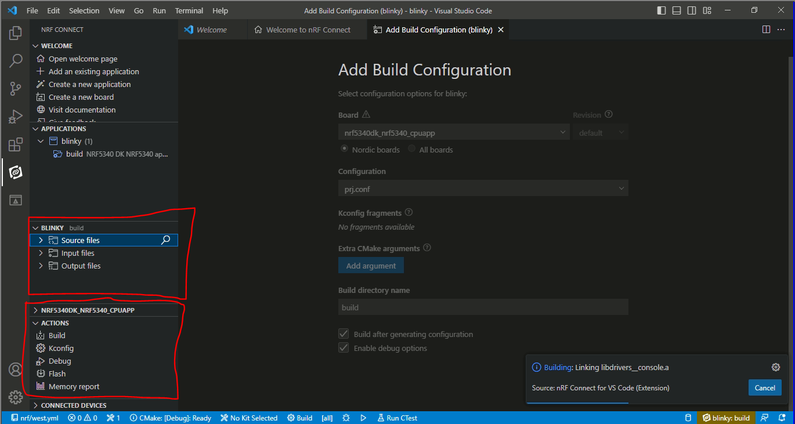
9. Connect your device and click on flash. 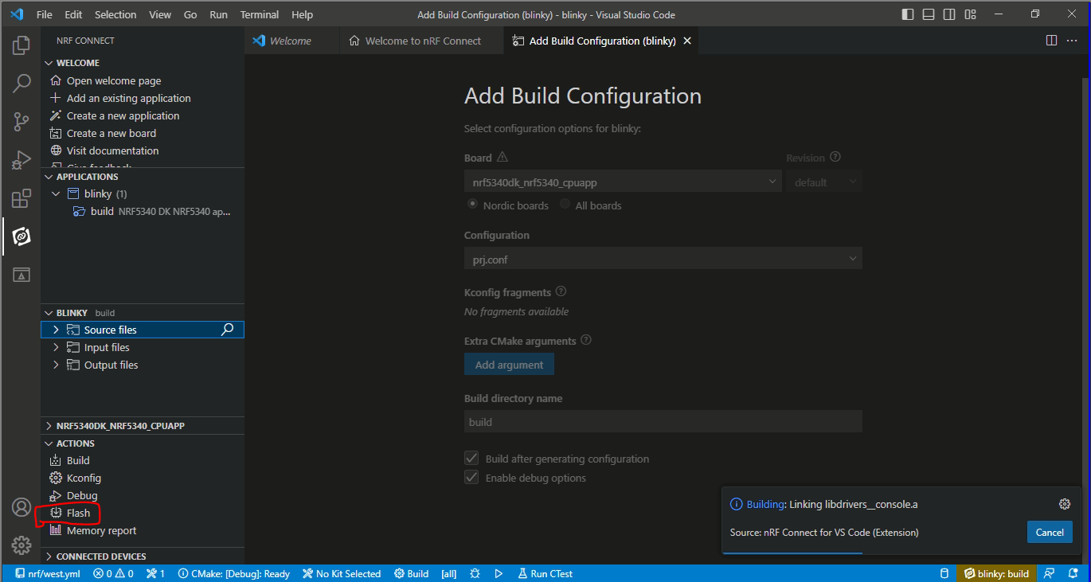

* If you make any changes in code don’t forget to build your code first and then flash.

IMP link- https://www.nordicsemi.com/Products/Development-tools/nRF-Connect-for-VS-Code/Tutorials